**Spark implementation for K-Means Clustering**

**Parallelization Strategy for Spark:**

To get started with K-Menas clustering we need to start with some initial data like Data Points and number of clusters to be used. I took a set of 169k points as input in the form of input file and as a team our goal was to achieve same clusters/ clusters with same centroids, by the end of execution. So to achieve that we took some predefined set of points as our initial centroids to get started. After setting up all the needed requirements I followed the below process to achieve parallelization through Spark.

*Note*: All the examples explained below are just to show how the syntax will look like but are not the actual calculations.

* I read the input file and mapped all the data points into a JavaRDD and I took some predefined set of points in a form of list which I named as “centroids”.
* I wrote a class named “**inputFilePraser.java**”, which will be taking the name of inputFile as input and will be using BufferedReader to reach each line and store all the points obtained from. Each line in a list named Points.
* To calculate the Euclidean Distance, I have written a new class named “Point.java” which will be taking 2 points as input and will be taking in the X and Y coordinates of both the points and will be calculating the distance using “**calculateDistance**” method.
* Step 1: Now my goal is to check which point from centroids list is closer to each point from my input. By doing this I can form an initial cluster. I will be generating a JavaPairRDD named “**centroidToClusterPair**” to store the centroid as key and input point as value.
  + I will be taking each point from the input dataset and will be calculating distance to every single centroid in my centroids list, and will be taking the centroid with shortest distance as my closes centroid to the point and will be storing it in the form of a tuple.
  + Ex: centroids = [(2,5),(3,6),(2,3)] point = (2,2)
    - I will be storing the Euclidean distance between two points in a variable named “***shortestDistance***”. Initially I have set my *shortestDistance* value to maxInteger, I have created a new object to store my *closestCentroid* Point and named it as “***closestCentroid***”.
    - Step1: Here I will be calculating Euclidian distance from (2,2) to first centroid (2,5), I will be storing this distance in a variable named “*currentDistance*” . Now the *currentDistance* will be 3, as our *shortestDistance* is much greater than *currentDistance*, we will be making our *shortestDistance* = *currentDistance* and our current *closestCentroid* will be (2,5).
    - Step 2: Calculate distance between (2,2) to second centroid (3,6). Now the *currentDistance* will be 4.123. As the *currentDistance* > *shortestDistance*(3), we won't be changing our *shortestDistance* and **closestCentroid**.
    - Step 3: Calculate distance between (2,2) and (2,3), *currentDistance* will be 1 which is smaller than *shortestDistance*(3). So, our *shortestDistance* will be *currentDistance* and the *closestCentroid* point will be set to current centroid.
    - After iterating through all the points in the centroids list, we will end up with one *closestCentroid* point which will become our key and the point will be our value, this tuple will be stored in *centroidToClusterPair*. The whole process repeats until all the points and their respective centroids are calculated.
* Step 2: Now that all the input pairs are assigned to some closest centroid, we will need to recalculate the mean of the cluster and check if the mean point is same as the current centroid. To check that in parallel it is difficult to just iterate through a for loop and attain the size of each cluster, we might end up with wrong values. So, to avoid this situation I have used hashmap named “**pointsPerCentroid**”, where I will be storing the centroid as key and to how many points it is assigned to as my value I.e... In “*centroidToClusterPair*” I have assigned all points with some centroids as their keys, to calculate the mean point of a cluster I need to know how many points are closer to a specific centroid that value can be known by performing a special function named “**countByKey()**”. I will be applying this function on “*centroidToClusterPair*” , this will return a hashmap with centroid as key and number of points it is assigned to as value.
  + Ex: { (2,3) : 100; (2,5) : 200; (3,6) : 300} (Ideally the size of this hashmap should be equal to k(that is the size of our initial centroids list)
* Step 3: After calculating total number of points that are assigned to a specific cluster, we need to know what is the summation of all the points that are present in that specific cluster. To calculate this, I will be storing centroids and summation values in the form of a JavaPairRDD named “**oldToNewCentroidUnDivided**”, the centroid point that all the points belong to will be stored as my key and the summation of all the points of a cluster will be stored in a single point, and this point will be my value in my hashmap. I will be taking “*centroidToClusterPair*” as my input and will be applying “reduceByKey()” function on it and will be storing all the values in a single point. My end result will be something like this { (2,3) : (1000,1000) ; (2,5) : (2000,2000) ; (3,6) : (3000,3000) }
* Now that we have calculated the summation of all the points in a cluster and how many points are assigned to each cluster, we are all set to calculate the mean of the cluster.
* Step 4: I have a Boolean variable named “**shouldStop**” set to true, this variable will help us in stopping the centroid calculation process. To calculate the mean of each cluster we will be iterating over “*oldToNewCentroidUnDivide*” hashmap. We will be taking each entry out of the above hashmap and will calculate the mean point, I have a boolean variable named “**centroidNotChanged**” which will check the values of oldCentroid and newCentroid, if points have not changed then *centroidNotChanged* will be set to True , and we will check if *shouldStop* and *centroidNotChanged* are True or not, if both the boolean variables are true then that means we have reached a convergence point and we can stop the clustering process.
  + Ex: *shouldStop* = True
    - OldToNewCentroidUnDivide = { (2,3) : (200,300) ; (2,5) : (2000,2000) ; (3,6) : (3000,3000) }
    - Lets take one entry from above HashMap, (2,3) : (100,100).
    - From Step 2 , for key(2,3) we will be getting “pointsPerCentroid” value as 100.
    - Now we have to check *centroidNotChanged*:
      * *centroidNotChanged* = ( (X coordinate value from key of centroid I from OldToNewCentroidUnDivide == ( X coordinate value of centroid I / pointsPerCentroid) && ((Y coordinate value from key of centroid I from OldToNewCentroidUnDivide == ( Y coordinate value of centroid I / pointsPerCentroid))
      * *centroidNotChanged* = ( 2 == (200/100) && 3 == (300/100))
      * *centroidNotChanged* = ( 2 == 2 && 3 == 3)
      * *centroidNotChanged* = True
      * *shouldStop* = *shouldStop* && *centroidNotChanged*
      * *shouldStop* = True && True
      * *shouldStop* = True
    - This process continues until all the entries in OldToNewCentroidUnDivide are calculated, if at this point *shouldStop* remains true, then this means that we have reached the convergence point and we can stop executing the program, else if *shouldStop* becomes False then we have to repeat all the steps from step1 to step4 till we reach the convergence point.

This was the overall parallelization strategy that I used to implement K-Means clustering process.

Source Code: (**SparkKMeansClustering.java**)

Step1: Calculate distance from point to all centroids.

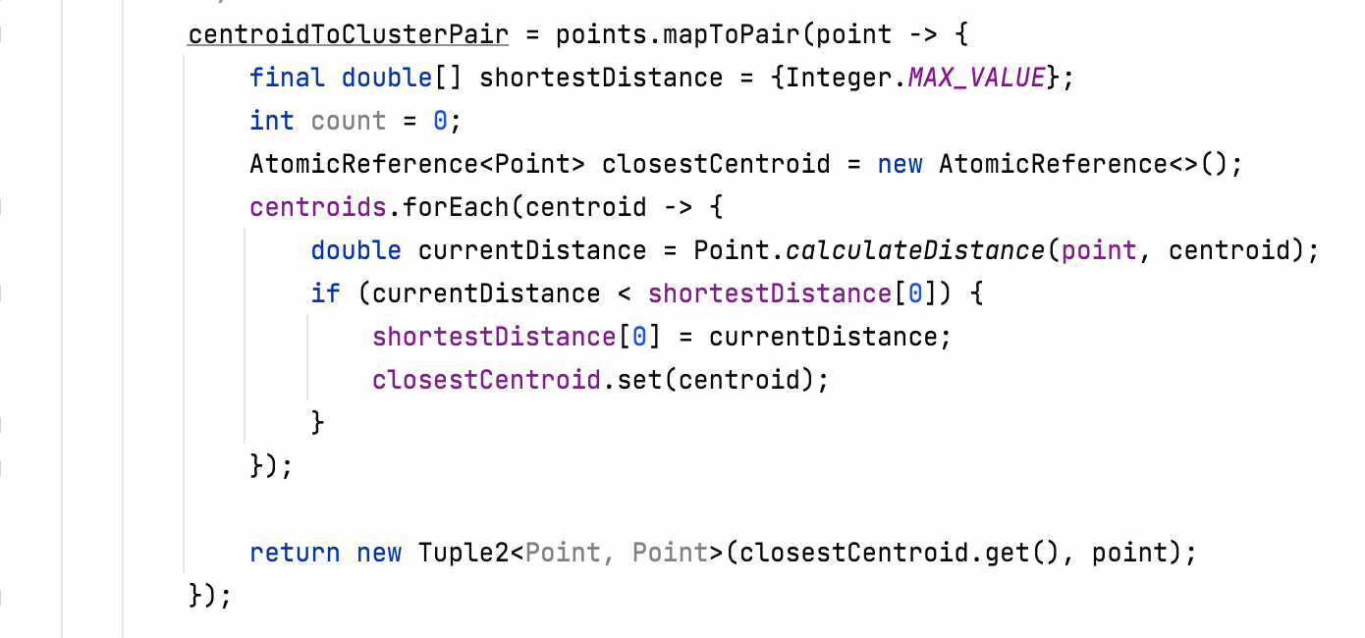

Step2: calculate # of points assigned to each cluster

Step3: Calculate summation of all X and Y coordinates that belong to one cluster.

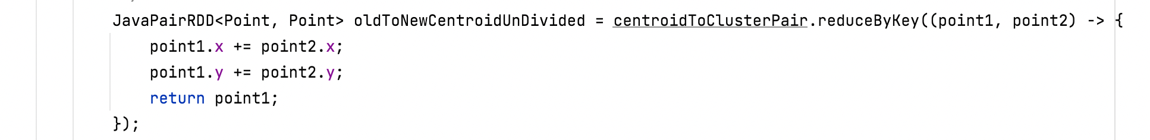Step4: check if we have reached convergence point

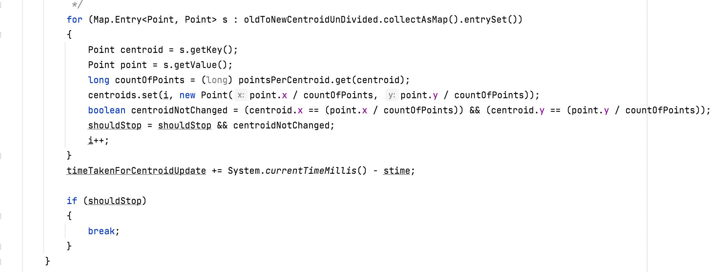

Execution outputs:

Output obtained by running single node:

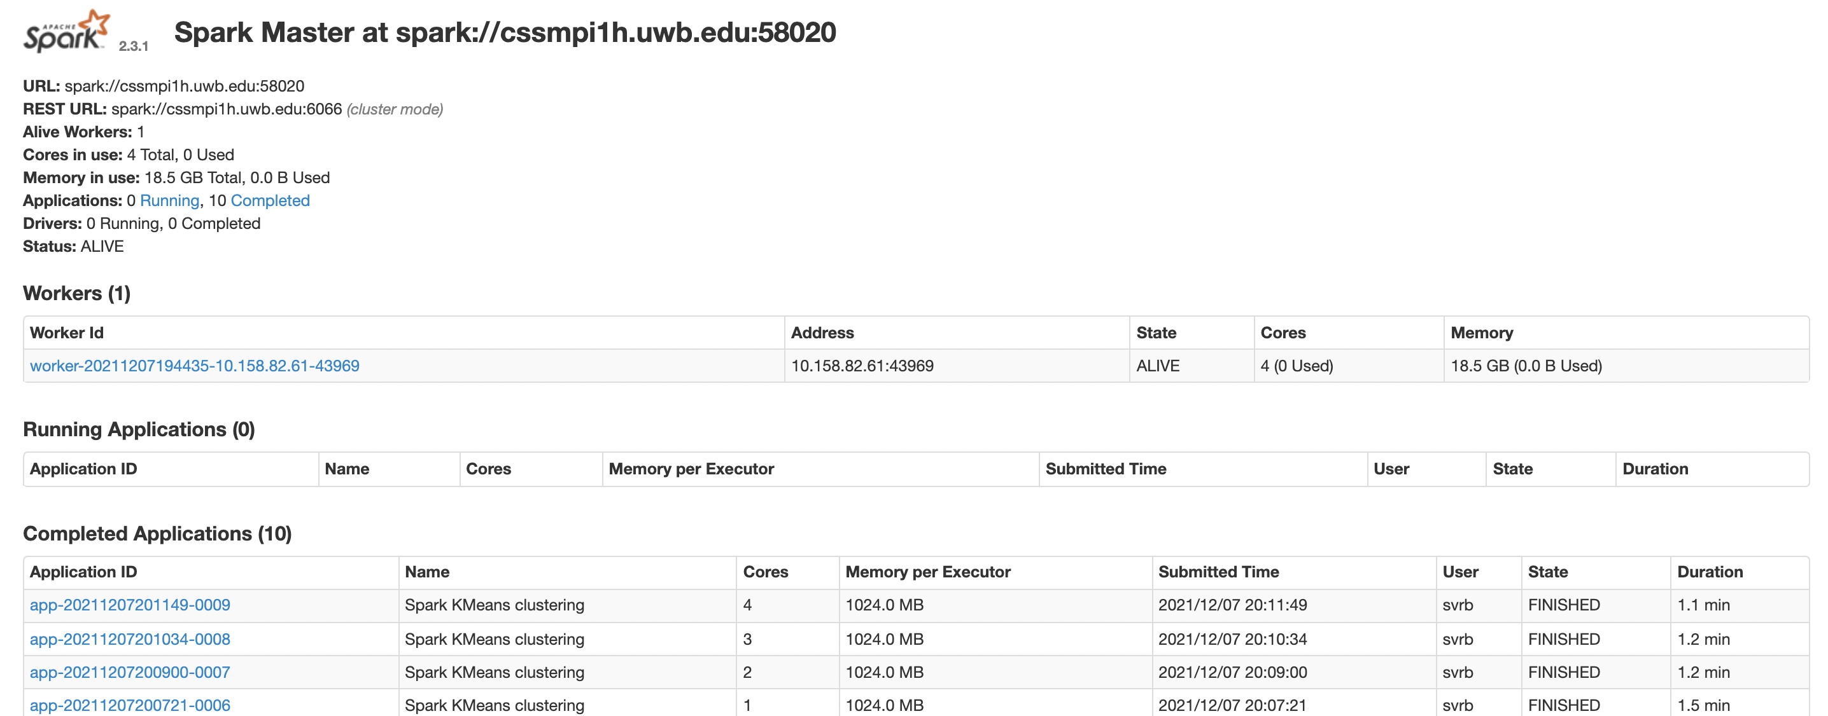

Output obtained by running 2 nodes:

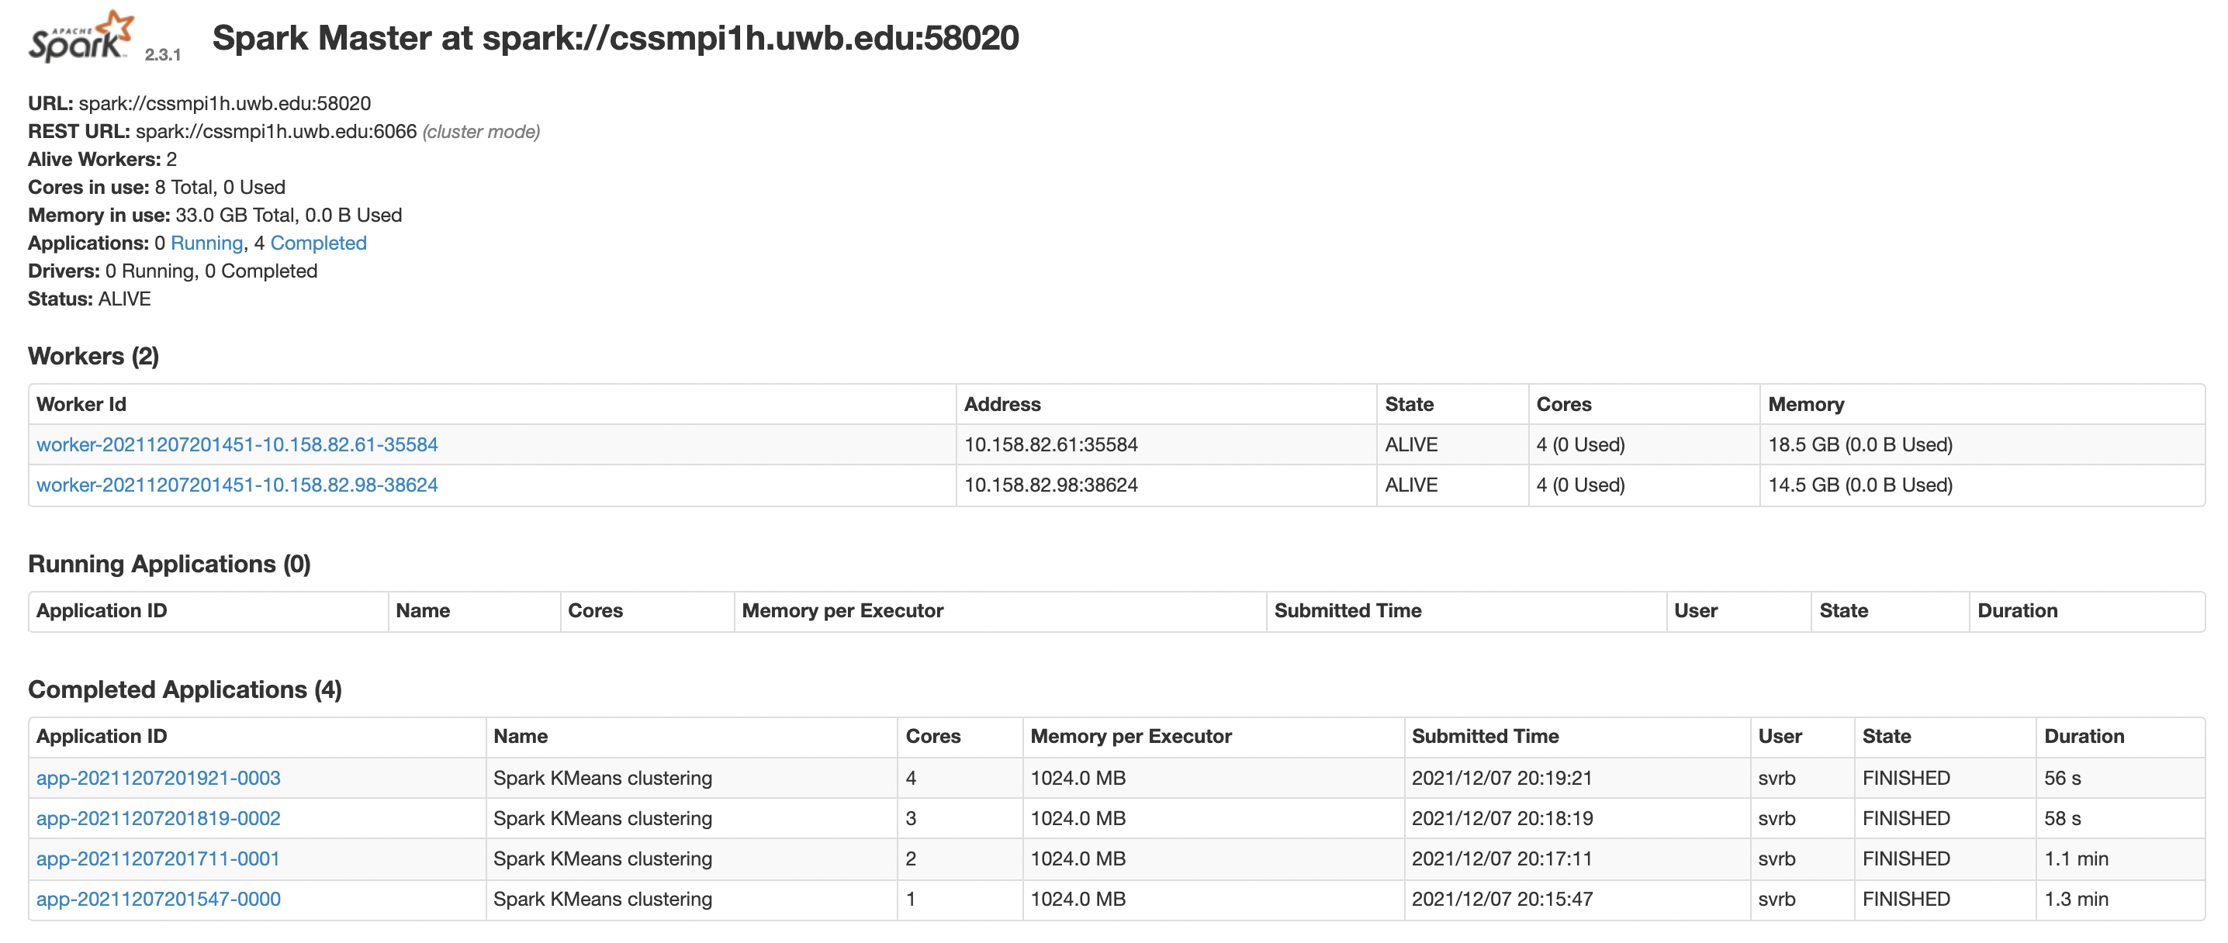

Output obtained by running 3 nodes:

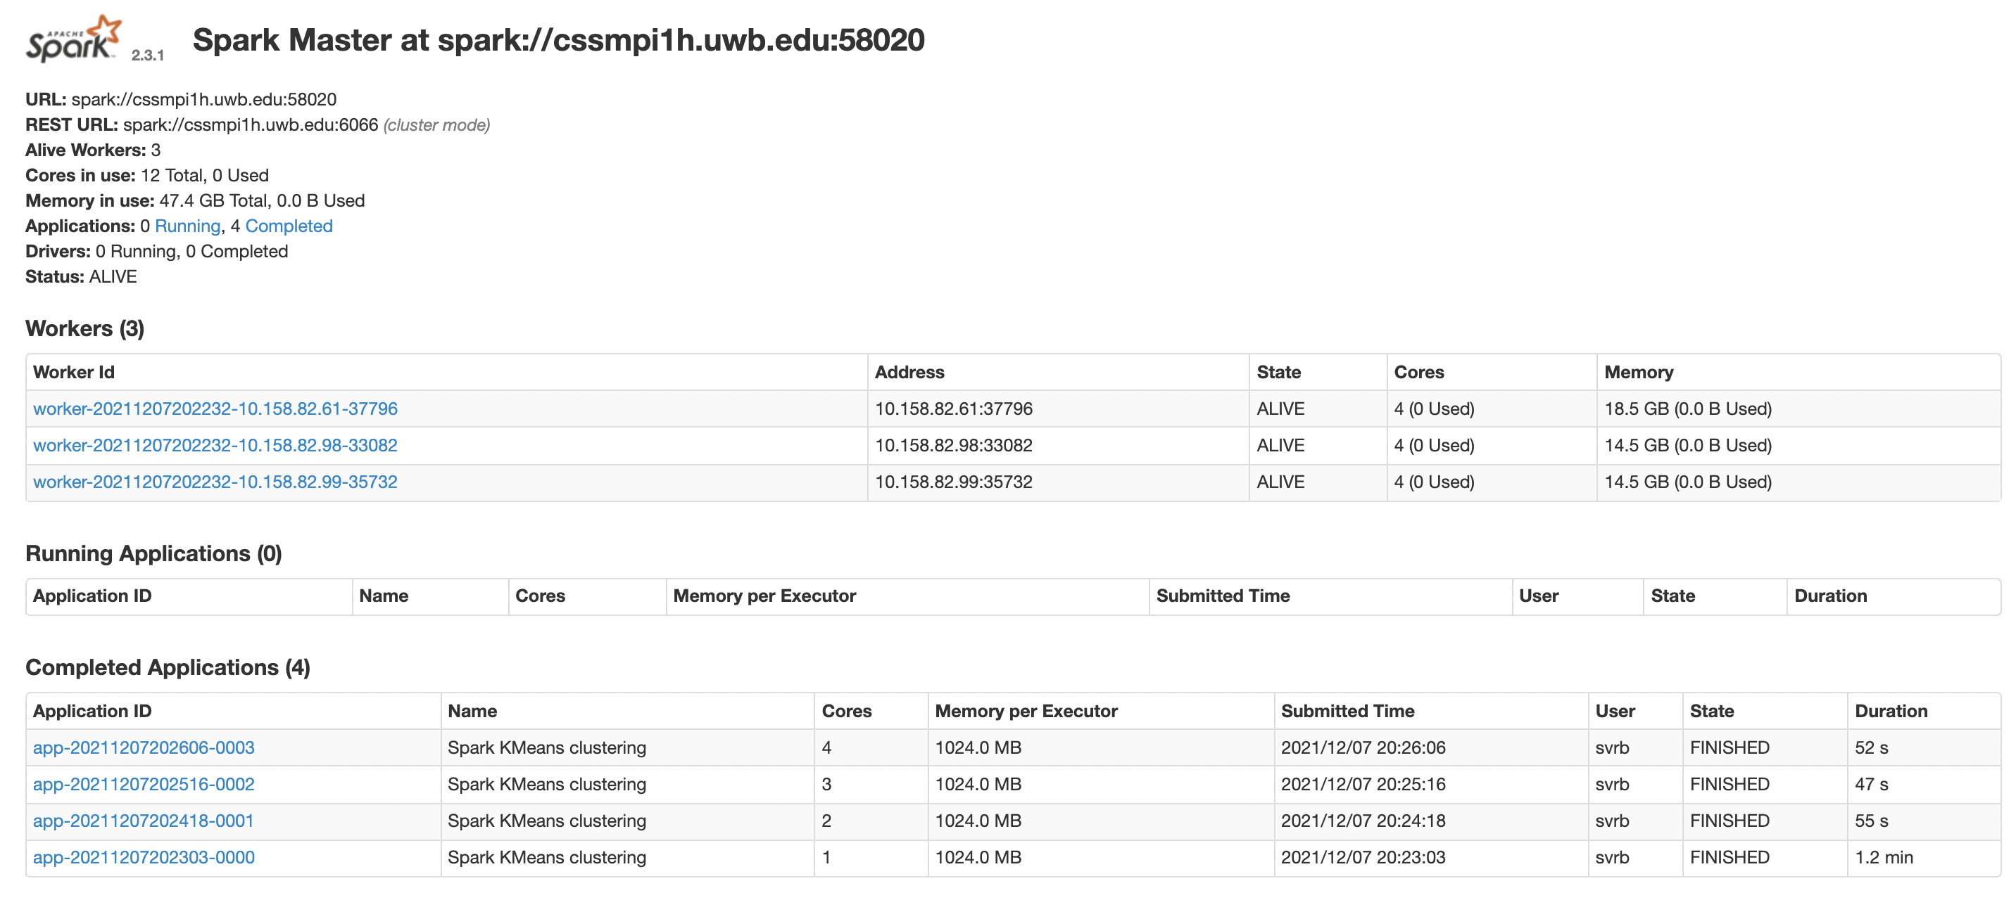

Output obtained by running 4 nodes:

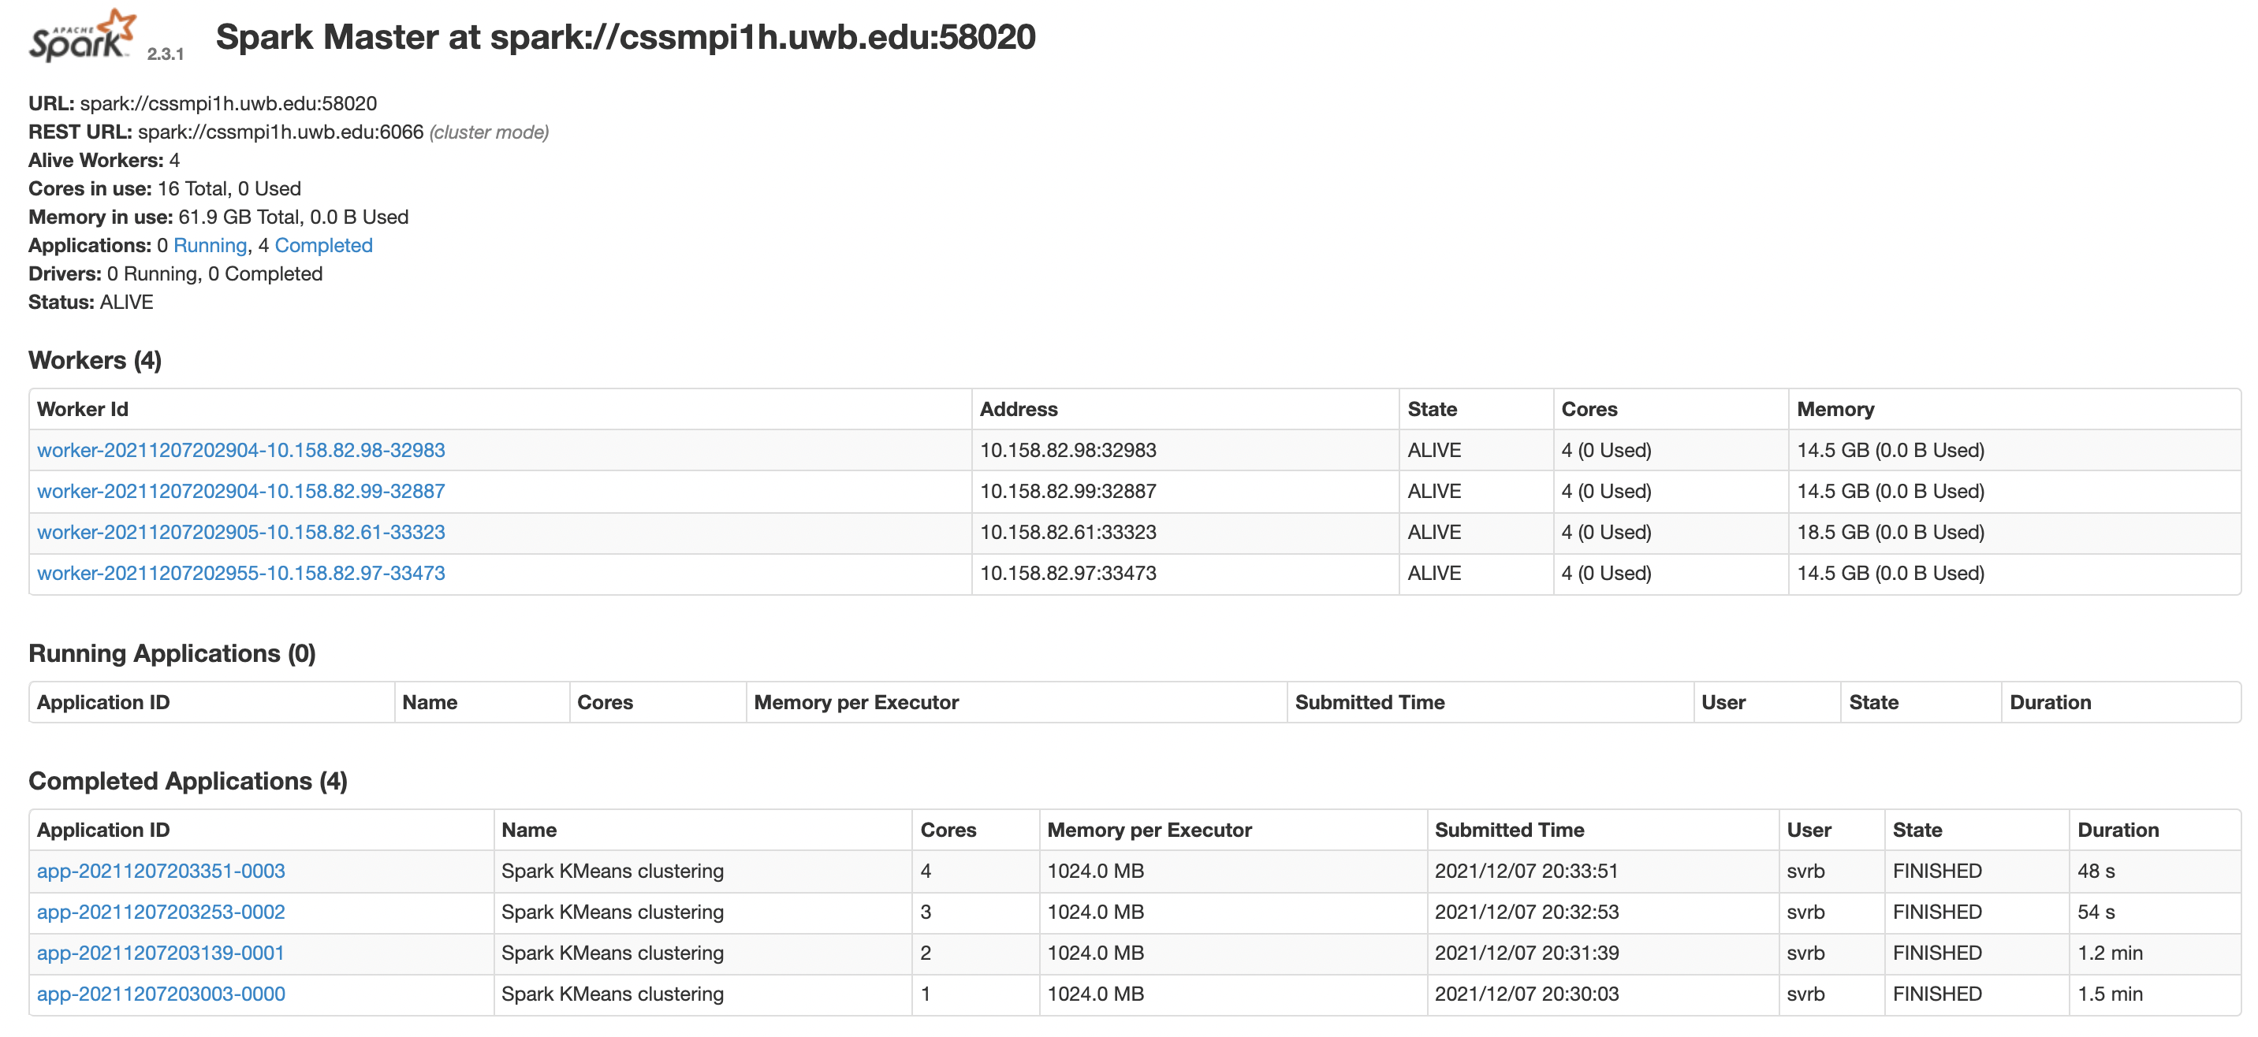

Output obtained by running 5 nodes:

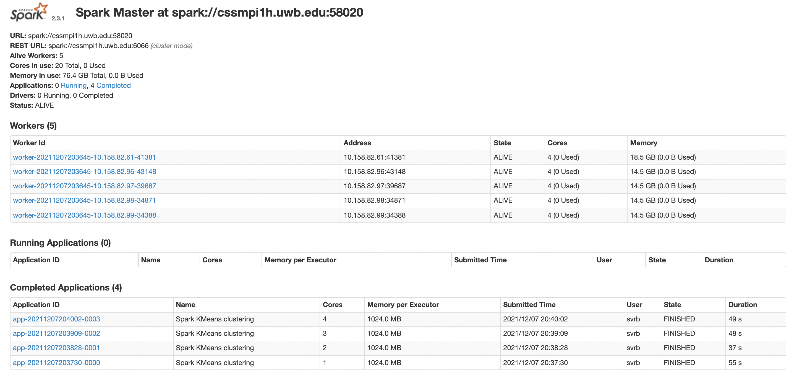

Output obtained by running 6 nodes:



Tabular Representation of all the Runtimes obtained from different nodes:

|  |  |  |  |  |
| --- | --- | --- | --- | --- |
| Number of Nodes | Number of Cores | Total # of cores | Elapsed Time | Performance Improvement |
| 1 | 1 | 1 | **86810ms** | **1.000** |
| 1 | 2 | 2 | 65382ms | 1.327 |
| 1 | 3 | 3 | 65810ms | 1.319 |
| 1 | 4 | 4 | 62694ms | 1.384 |
| 2 | 1 | 2 | 73748ms | 1.177 |
| 2 | 2 | 4 | 60421ms | 1.436 |
| 2 | 3 | 6 | 54259ms | 1.599 |
| 2 | 4 | 8 | 50248ms | 1.727 |
| 3 | 1 | 3 | 67617ms | 1.283 |
| 3 | 2 | 6 | 51102ms | 1.698 |
| 3 | 3 | 9 | 43213ms | 2.008 |
| 3 | 4 | 12 | 48503ms | 1.789 |
| 4 | 1 | 4 | 83810ms | 1.035 |
| 4 | 2 | 8 | 64883ms | 1.337 |
| 4 | 3 | 12 | 49169ms | 1.765 |
| 4 | 4 | 16 | 44329ms | 1.958 |
| 5 | 1 | 5 | 51846ms | 1.674 |
| 5 | 2 | 10 | **34555ms** | **2.512** |
| 5 | 3 | 15 | 44018ms | 1.972 |
| 5 | 4 | 20 | 44876ms | 1.934 |

Best Performance Improvement = (86810/34555) = 2.51 times

**Programmability Analysis:**

* Contains very less amount of boilerplate code.
* Initially the execution time for more than 1 node took nearly 10 to 20 minutes which was shocking because it took a lot of time to calculate the number of points assigned to each cluster, which is when I used countByKey() function which improved my runtime drastically. That was the only part of the program which took a lot of time for execution.
* Once I came to know what are the best data structures and functions that can be utilized, programming part was not that hard to implement.
* For a person to implement this algorithm in Spark, they should have profound knowledge of most of the functions available in Spark.
* Overall, it took a lot of time to think and articulate the code in a well-mannered fashion, but I didn’t face any issues while execution.